Photo By: Stephanie
I like how you made the picture black and white. it gives it a very vintage feel. I also like that at the very bottom of the photo you can see just a bit of the fence in the foreground and the background. It just gives the illusion of the plane actually flying.
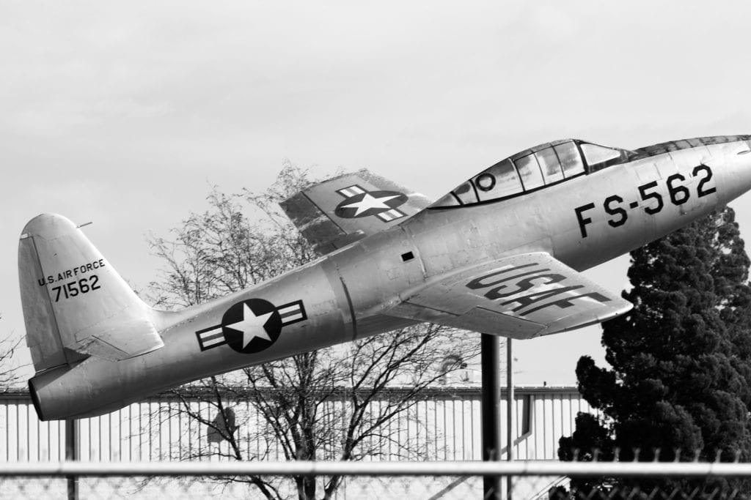

Photo By: Jackson M.
I love how the sun hits the center of the plane. Especially with the star in the center because it just highlights it even more. I also like the clouds in the background, they almost look like fog coming off the plane, and it adds more texture to the picture.

Photo By: Clara
I like that there are so many things in this photo that are so pretty. I love all the different vibrant colors that really make the picture pop. I also love that they main colors are red and green, they give off very good Christmas vibes.
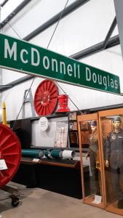

Photo By: Medea
With only the bottom half of the face visible, it's kind of a freaky picture. But that's what I like about it. I feel like it gives so much mystery to the picture and leave the viewer wondering what’s going on with this guy.
